THE BOARD OF TRUSTEES

OF THE VILLAGE OF ROCA

MINUTES OF MEETING

DATE: June 9, 2025

TIME: 7:00 p.m.

LOCATION: Roca Community Center

15545 B St

Roca NE 68430

MEMBERS PRESENT AND OPEN MEETING ACT NOTIFICATION

Board member(s) present: Shawn Hemenway, Zack Goering, Ralph Anderson, Steve Ossowski. Chairman Chris Ibsen convened the meeting at 7:00 pm in compliance with the Public Meeting Requirements. Notice of the meeting was published in The Voice. Notification was given to the public of the open meetings law and notification to its location for public view.

APPROVAL OF MEETING MINUTES

Goering moved, seconded by Hemenway to approve the minutes from May 12, 2025.Voting aye: Ibsen, Hemenway, Goering, Anderson, Ossowski. Motion carried.

APPROVAL OF TREASURER’S REPORT, RECEIPTS & DISBURSEMENTS

Anderson moved, seconded by Hemenway, to approve the treasurer’s report and disbursements as follows:

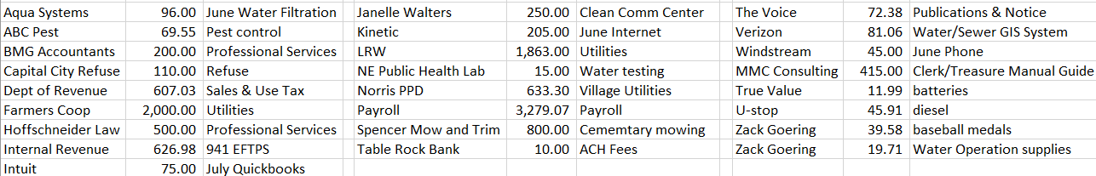

Voting aye: Ibsen, Ossowski, Anderson, Hemenway. Motion carried. Goering abstained.

MEETINGS WITH ASSOCIATIONS

Cemetery - none.

Planning Commission/Bldg.- Planning Commission approved Brandt Plat request.

Park/Roads – none

Water/Sewer – John Nanos attended to discuss Moormeier development and sewer study. Water rate ordinance draft for review. Water meter install letters going out.

ADJOURNMENT

Hemenway moved, seconded by Anderson to adjourn the meeting at 7:58 pm. Voting aye: Hemenway, Goering, Ibsen, Anderson, Ossowski. Motion carried.

Respectfully submitted,

Kristi Denison, Clerk/Treasurer

Village of Roca