THE BOARD OF TRUSTEES

OF THE VILLAGE OF ROCA

MINUTES OF MEETING

DATE: May 12, 2025

TIME: 7:00 p.m.

LOCATION: Roca Community Center

15545 B St

Roca NE 68430

MEMBERS PRESENT AND OPEN MEETING ACT NOTIFICATION

Board member(s) present: Shawn Hemenway, Zack Goering, Ralph Anderson. Chairman Chris Ibsen convened the meeting at 7:00 pm in compliance with the Public Meeting Requirements. Notice of the meeting was published in The Voice. Notification was given to the public of the open meetings law and notification to its location for public view.

APPROVAL OF MEETING MINUTES

Hemenway moved, seconded by Anderson to approve the minutes from April 14, 2025.Voting aye: Ibsen, Hemenway, Goering, Anderson. Motion carried.

APPROVAL OF TREASURER’S REPORT, RECEIPTS & DISBURSEMENTS

Goering moved, seconded by Anderson, to approve the treasurer’s report and disbursements as follows:

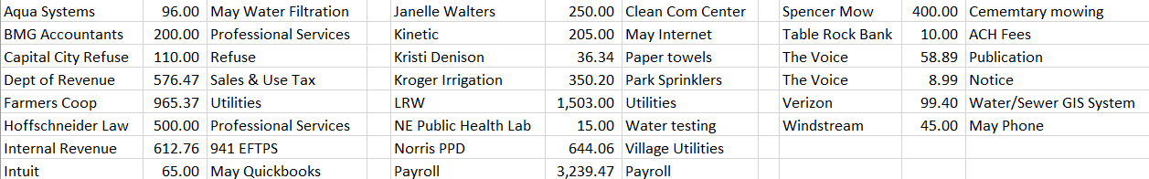

Voting aye: Ibsen, Goering, Anderson, Hemenway. Motion carried.

CRAZY CRACKER FIREWORKS PERMIT

Anderson moved, seconded by Goering to approve Crazy Cracker Fireworks application contingent on proof of insurance. Voting aye: Ibsen, Hemenway, Goering, Anderson. Motion carried.

MEETINGS WITH ASSOCIATIONS

Cemetery - none.

Planning Commission/Bldg.- none

Park/Roads – Pavers quotes presented, culvert work discussed.

Water/Sewer – none

ADJOURNMENT

Hemenway moved, seconded by Anderson to adjourn the meeting at 7:24 pm. Voting aye: Hemenway, Goering, Ibsen, Anderson. Motion carried.

Respectfully submitted,

Kristi Denison, Clerk/Treasurer

Village of Roca