THE BOARD OF TRUSTEES
OF THE VILLAGE OF ROCA
MINUTES OF MEETING

DATE: March 10, 2025

TIME: 7:00 p.m.

LOCATION: Roca Community Center
15545 B St
Roca NE 68430

MEMBERS PRESENT AND OPEN MEETING ACT NOTIFICATION
Board member(s) present: Shawn Hemenway, Zack Goering, Steve Ossowski, Ralph Anderson. Chairman Chris Ibsen convened the meeting at 7:00 pm in compliance with the Public Meeting Requirements. Notice of the meeting was published in The Voice. Notification was given to the public of the open meetings law and notification to its location for public view.

APPROVAL OF MEETING MINUTES
Hemenway moved, seconded by Anderson to approve the minutes from February 10, 2025.Voting aye: Ibsen, Hemenway, Goering, Ossowski, Anderson. Motion carried.

APPROVAL OF TREASURER’S REPORT, RECEIPTS & DISBURSEMENTS
Ossowski moved, seconded by Hemenway, to approve the treasurer’s report and disbursements as follows:
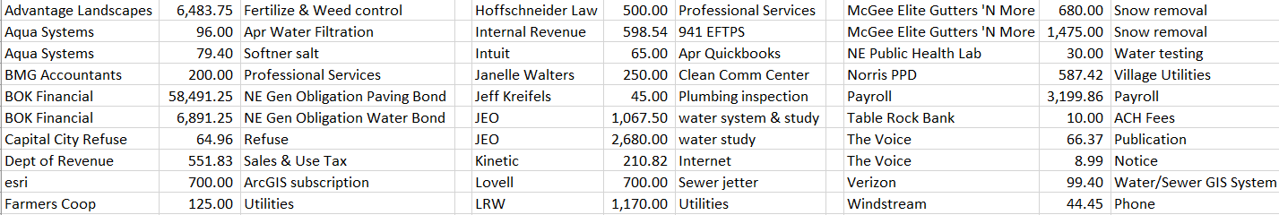
Voting aye: Ibsen, Goering, Ossowski, Anderson, Hemenway. Motion carried.

NORTHLAND SECURITIES
Jerel Saltzman presented various investment options for the village.

MEETINGS WITH ASSOCIATIONS
Cemetery - none.
Planning Commission/Bldg.- address assignment
Park/Roads – sprinklers and bathrooms open soon weather permitting
Water/Sewer – delinquent accounts, SCADA system

EXECUTIVE SESSION
Goering moved, seconded by Anderson to go into an Executive Session at 8:06pm to discuss village growth. Voting aye: Hemenway, Goering, Anderson, Ossowski, Ibsen. Motion carried. Goering moved, seconded by Ossowski to adjourn the session at 8:33 pm. Voting aye: Hemenway, Goering, Anderson, Ossowski, Ibsen. Motion carried.

MOORMEIER DEVELOPMENT
Discussed water study results for possible development. Going forward with sewer study.

ADJOURNMENT
Goering moved, seconded by Hemenway to adjourn the meeting at 8:38 pm. Voting aye: Hemenway, Goering, Ibsen, Ossowski, Anderson. Motion carried.

Respectfully submitted,
Kristi Denison, Clerk/Treasurer
Village of Roca

